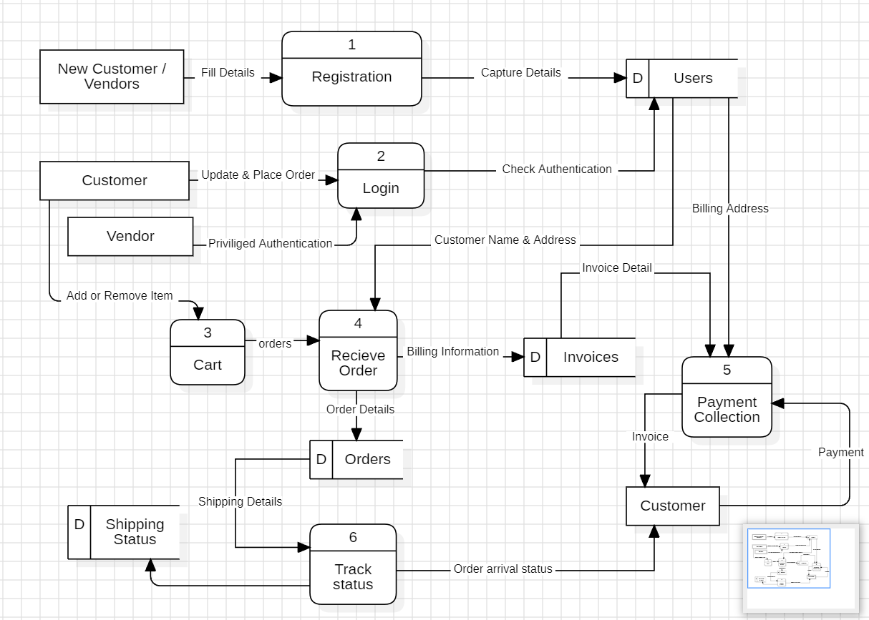

Fig: Data Flow Diagram Level 1 Of E-Commerce Application